ACE RMO CV Template for PGY1 Applications 2022
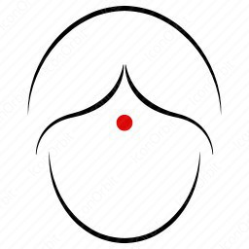
Photo is optional. Remove Icon

Personal Information

Name
Postal Address
Email Address
Contact Phone | Mobile:  Home:

Personal Statement
In one to two paragraphs write your personal statement here introducing yourself and including your objectives and career aspirations. You may also wish to include a Whakataukī here as well. Consider your values, interests, personality professional and clinical skills.

Education

List in reverse chronological order your degree(s) and any additional qualifications and high school information
2022 | MBChB/MBBS | University, Location
2020 | Master of Public Health | University, Location
2018 | Bachelor of Health Science | University, Location
2016 | Scholarship Bursary/NCEA | College, Location

Clinical Attachments Experience

List attachments between Years 4 and 6 in reverse chronological order. Include any upcoming attachments. Include Elective and/or Selective Experience
Attachment Dates | Position | Attachment | Location
Q2 2022 | TI | Surgery | xDHB
Q1 2022 | TI | Medicine | xDHB

Work Experience

List any work experience in reverse chronological order
Employment Dates | Position | Place of Employment | Roles/Responsibilities
Feb 2021 - Present | Retail Assistant | The Ski Shop | Customer service etc.

Voluntary Work Experience

Employment Dates | Position | Place of Employment | Roles/Responsibilities
Jun 2020 – Aug 2022 | Peer Counsellor | Lifeline etc | Highlight proven skills, discuss attributes

Academic Achievements

Awards & Prizes
Year | Name of award | Awarded by

Presentations
Year | Name of Conference/Seminar | Title/Subject

Publications
Year | Publication Name | Authors | Title/Subject

Research
Year | Research Type | Title of Research | Supervisor(s)

Posters
Year | Name of Conference/Seminar | Title/Subject | Did you present the poster?

Extracurricular Interests

Employers like to know what your interests are outside of Medicine. Do you belong to any sports teams or societies; do you play musical instrument(s); are you fluent in other languages; are you part of stage/theatre productions etc?
In one to two paragraphs write your interests here.

